**Chain rule**

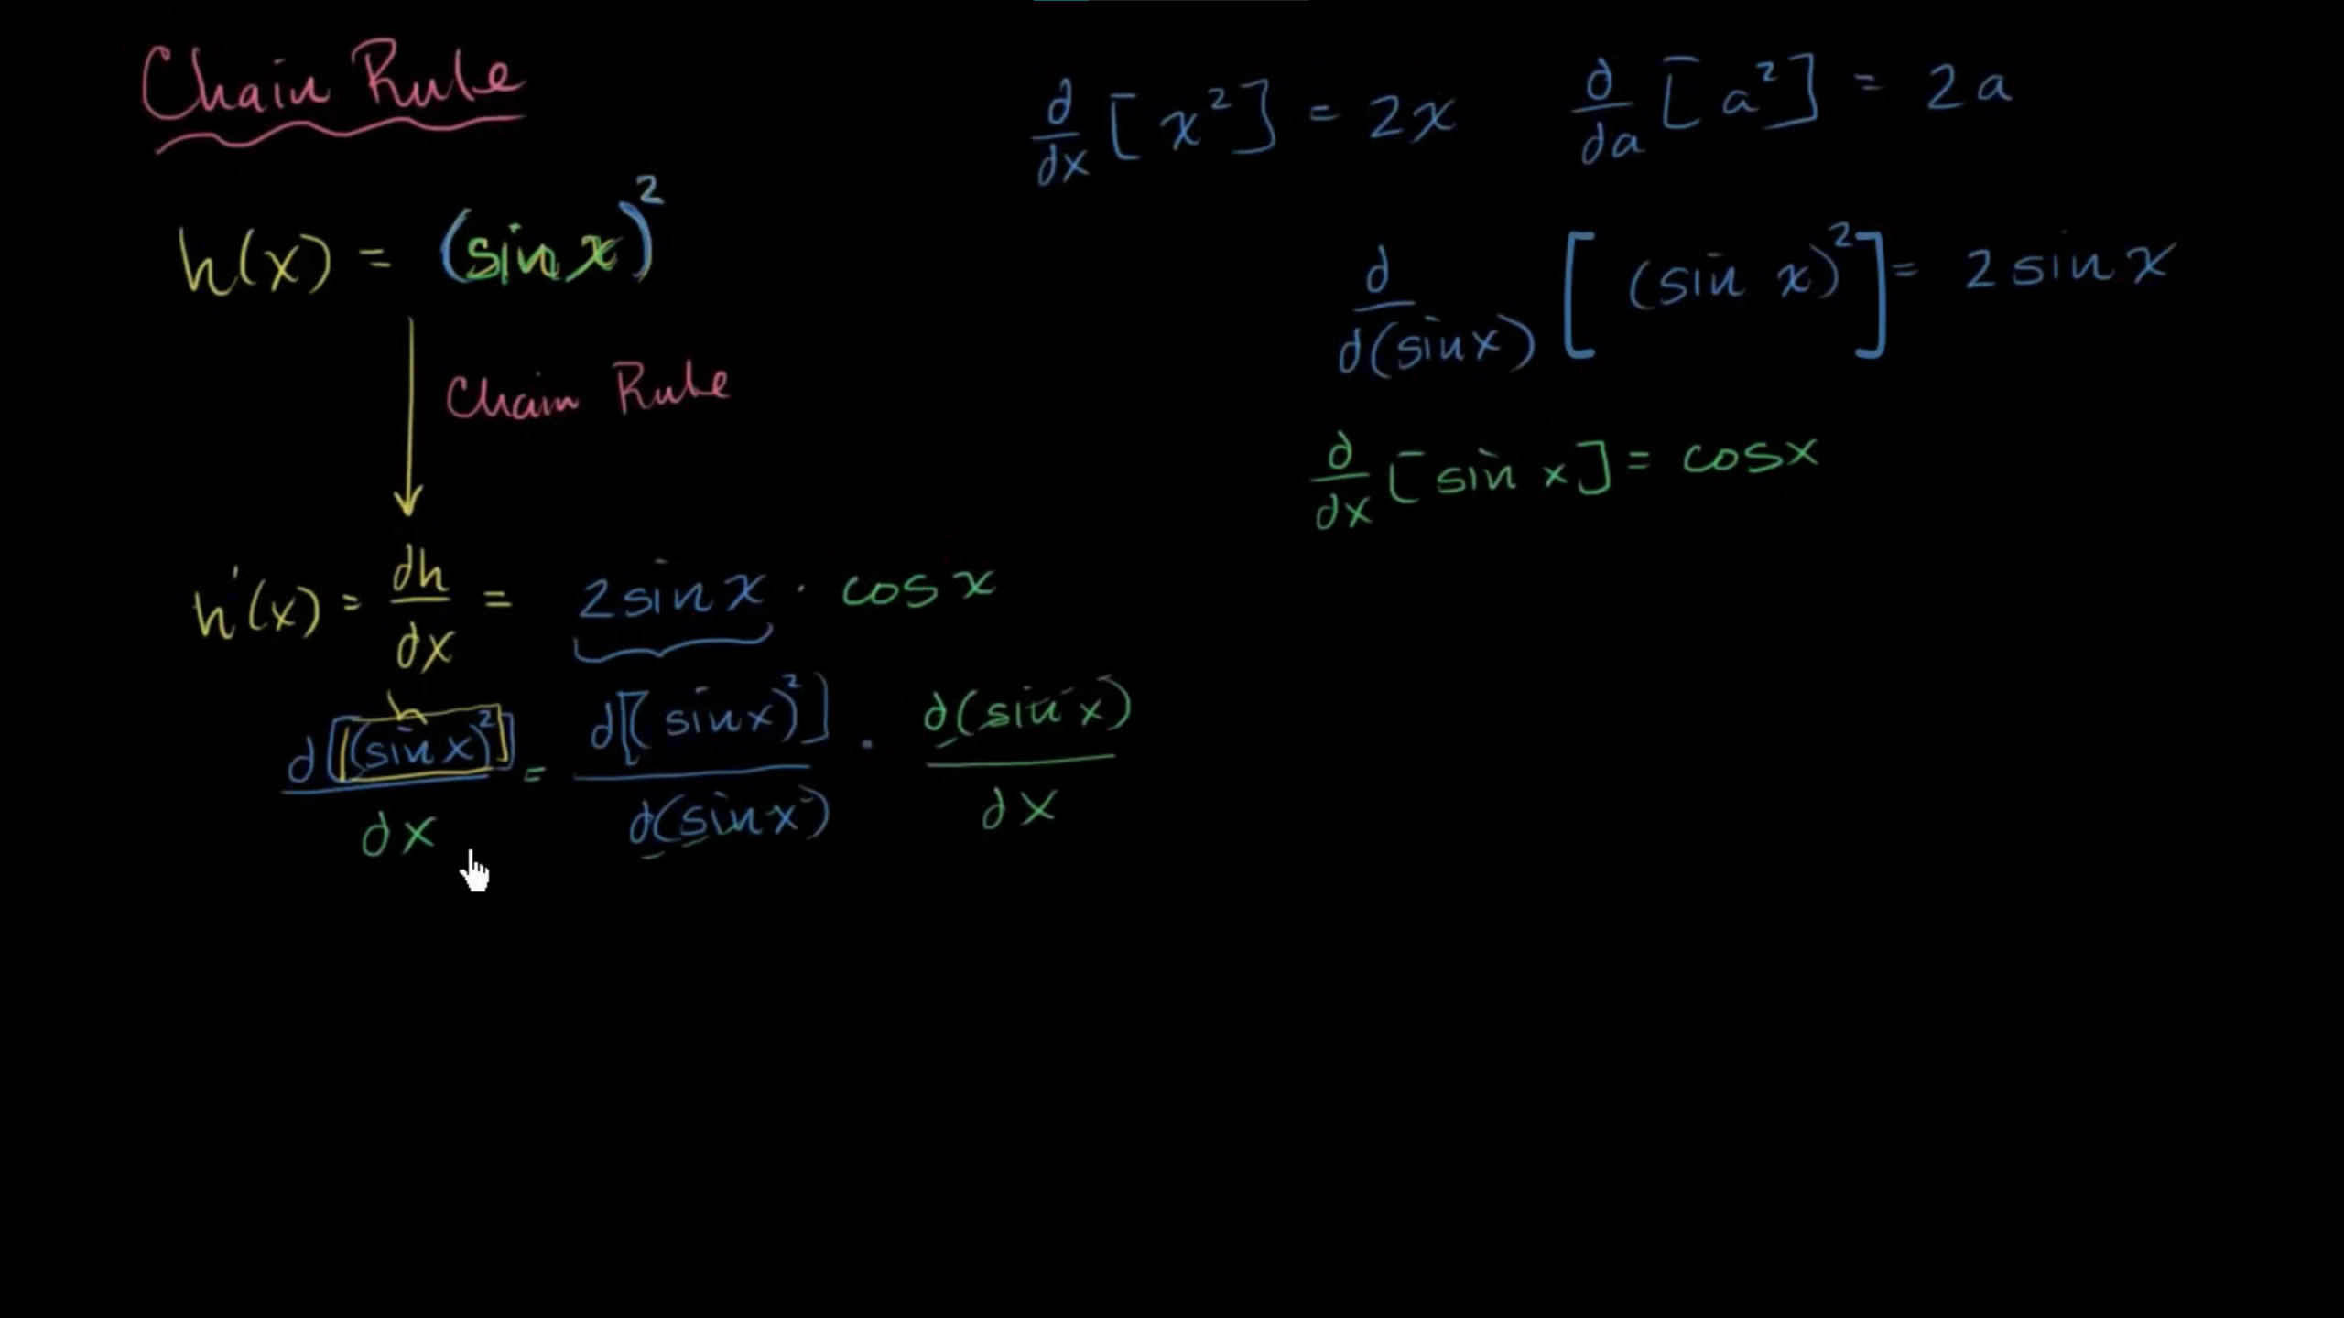

**Common chain rule misunderstandings**

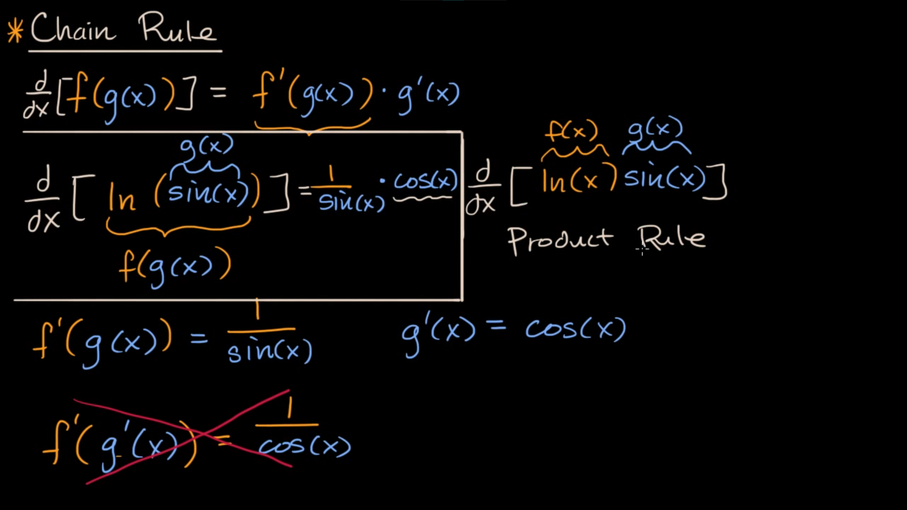

**Identifying composite functions**

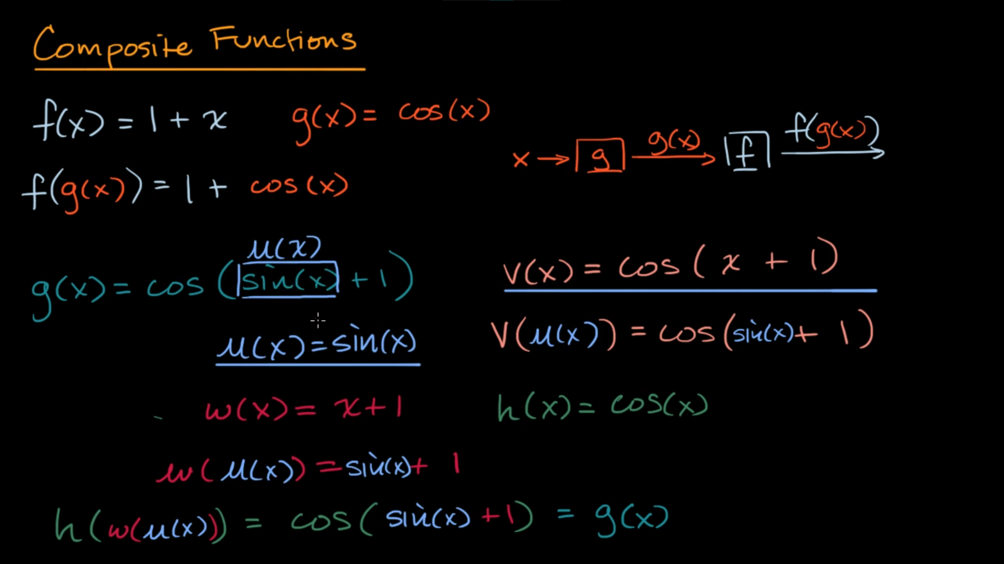

**Worked example: Derivative of cos³(x) using the chain rule**

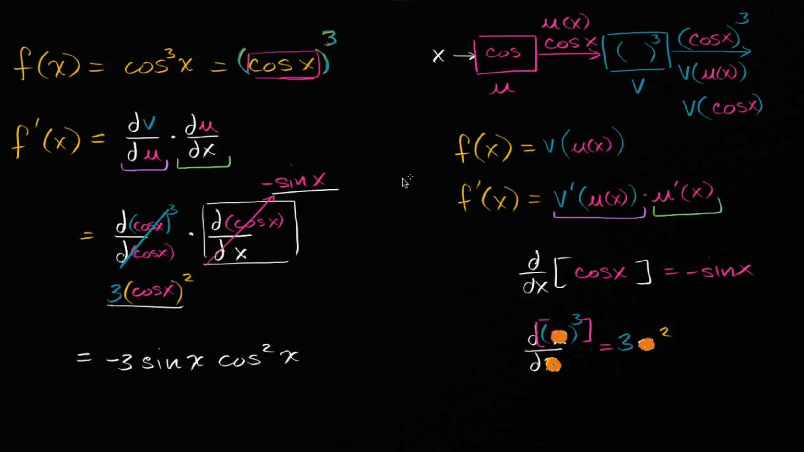

**Worked example: Derivative of √(3x²-x) using the chain rule**

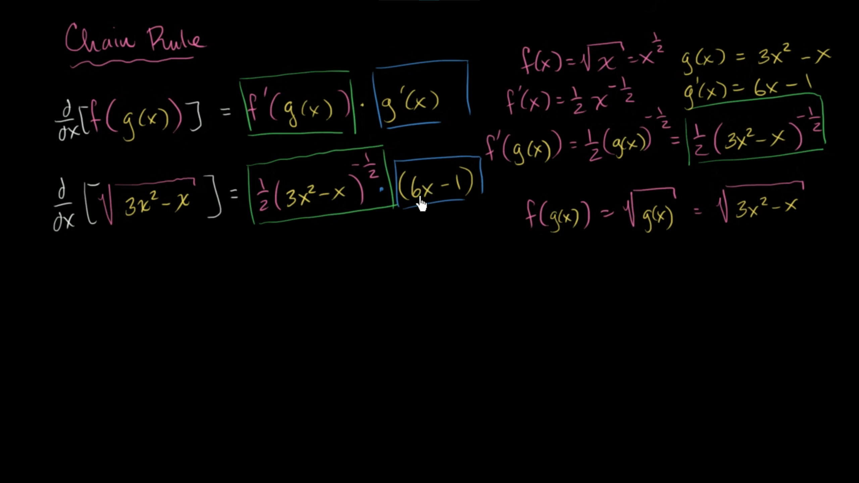

**Worked example: Derivative of ln(√x) using the chain rule**

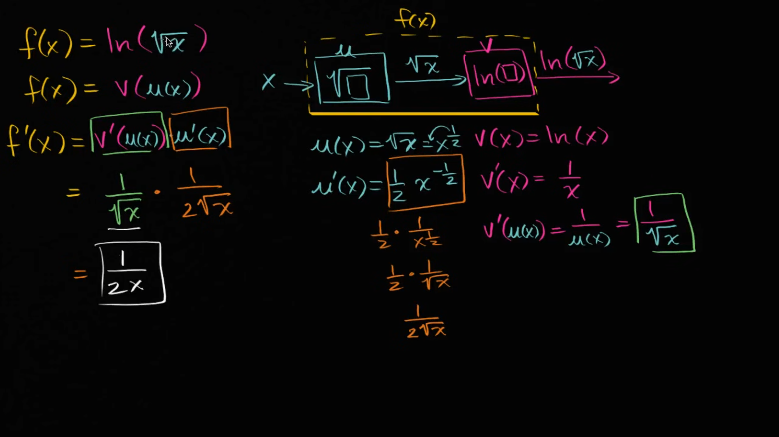

**Worked example: Chain rule with table**

